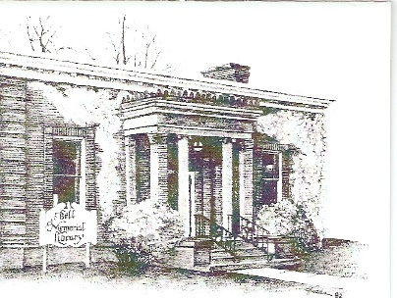
Collection Policy
The Library believes it is essential in a free society that all citizens have access to library materials and that no restrictions are placed on what anyone may read, see, or hear in a public library’s collection.

The Library agrees with the principles articulated in the American Library Association’s Freedom to View; Library Bill of Rights; Free Access to Library Materials for Minors; Freedom to Read; and Statement on Labeling.

Well-intentioned persons or groups occasionally question the appropriateness of specific items in library collections, or the effects some materials may have on impressionable persons. Suggestions are sometimes made regarding the restriction, removal, or labeling of certain library materials. The Library understands and appreciates these suggestion and concerns but believes the risk of not providing free access to information and ideas is greater than the risk of providing it. The Library, therefore, enunciates the following principles:

Controversial Materials: In an effort to provide patrons with diverse sources of information and the widest possible range of ideas and viewpoint, it acquires materials that may be controversial because of profanity, social, economic, or political ideas, religious viewpoints, the background of the author, the kinds of information provided, or other reasons. Acquisitions or use of any item does not imply approval or endorsement of the contents.

Ages: The age of a patron will not be the sole determining factor in the circulation of Library materials. If parents/guardians wish to limit their children’s access to certain materials, that is their responsibility and not the Library’s.

Labeling: It is sometimes suggested that a label be affixed to library materials indicating a political or social point of view or indicating that such an item is questionable or controversial. Such labeling suggestions that people are incapable of making up their own minds about controversial subjects. The Library does not subscribe to this practice.

Review of Library Selections: The Library is willing to review its selection of items in its collections on a case by case basis. Individuals who question the appropriateness of specific items may initiate such a review by submitting their concerns to the Library Manager in writing using the ‘Collection Complaint Form’ available at the service desk. The review process includes a full reading, hearing, or listening of the item by the Library Manager and by the individual requesting the review. The Library Manager will meet with the individual and report her/his findings to the Library Board of Trustees. No item is to be removed or restricted because of a complaint until after the Board has examined the individual’s request and the findings of the Library Manager.

ADOPTED: 3/17/1995
REVISED: 10/22/2020

