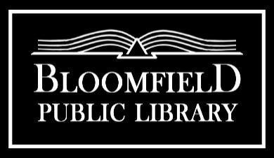

Board Meeting Agenda
Monday, September 16th 7PM

Call to Order:
1. | Public Comment Period | Cydney Badger
2. | September 16th, 2024 Agenda | Cydney Badger | Action: Approve | 2409-1
3. | Minutes of the August 19th Meeting  Minutes of August 12th Board Meeting | Cydney Badger | Action: Approve | 2409-2

Communication and Reports:
1. | Treasurer Report | Donna Wollschleger | Action: Approve | 2409-3
2. | Financial Reports  - Warrants (list of bills paid)  - Cash Activity Report  - YTD Report | Donna Wollschleger | Action: Approve  Action: Approve  Action: Approve | 2409-4a  2409-4b  2409-4c
3. | Director’s Report | Rachael Aycock | Action: Approve | 2409-5
4. | Committee Reports  - Budget/Finance/Personnel  - Governance  - Facility  - Planning |  | Action: Approve | 2409-6
5. | Friends Liaison Report |  | Action: Review | 2409-7

Old Business:
1. | Employee Handbook | Personnel Committee | Action: Approve | 2409-8
2. | FOTL MOU | Rachael Aycock | Action: Update | 2409-9

New Business:
1. | Petty Cash Policy | Rachael Aycock | Action: Approve | 2409-10
2. | Confidentiality of Library Records Policy | Rachael Aycock | Action: Approve | 2409-11
3 | Bill Pay Policy | Rachael Aycock | Action: Approve | 2409-12
4. | Green Client with ConnectPay | Cydney Badger | Action: Approve | 2409-13
5. | Exempt Status- Rachael Aycock | Cydney Badger | Action: Approve/Assign Action | 2409-14
6. | Library Closures Update | Cydney Badger | Action: Approve | 2409-15
7. | Library Rebranding/Social Media | Rachael Aycock | Action: Discuss | 2409-16
8. | Facility Update | Rachael Aycock | Action: Discuss | 2409-17

Reminders:
1. | Next Meeting is October 21st, 2024

Adjourn:

